Azure Assignment

(AZ – 104- Module 7)

Avishekh Sinha

# Module 7 – AZURE NETWORKING- II

## Assignment 1

1. Deploy 2 VMs with ubuntu and apache2 installed

2. Change index.html to include the following text

a. “This is VM1” on VM1

b. “This is VM2” on VM2

3. Create a load balancer which will balance the traffic between these two VMs

1. DEPLOYING VM – Ubuntu VM are deployed

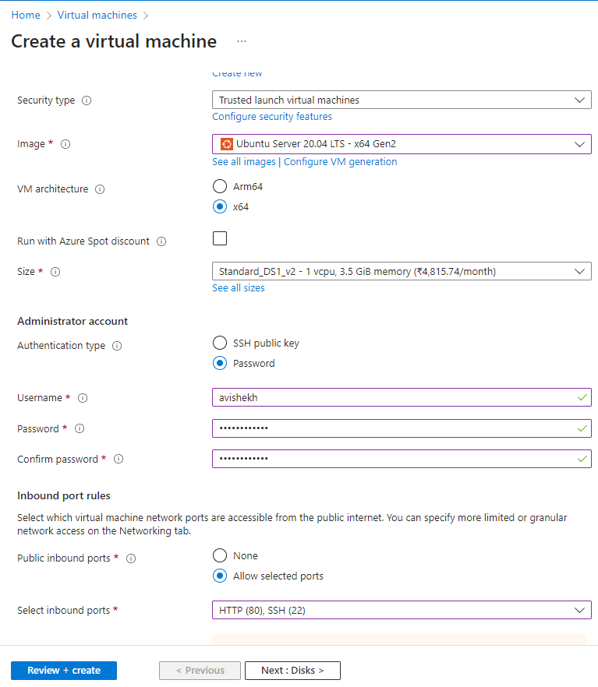

INSTALLING APACHE

1. TO UPDATE THE PACKAGES : sudo apt-get update
2. TO INSTALL APACHE: sudo apt install apache2

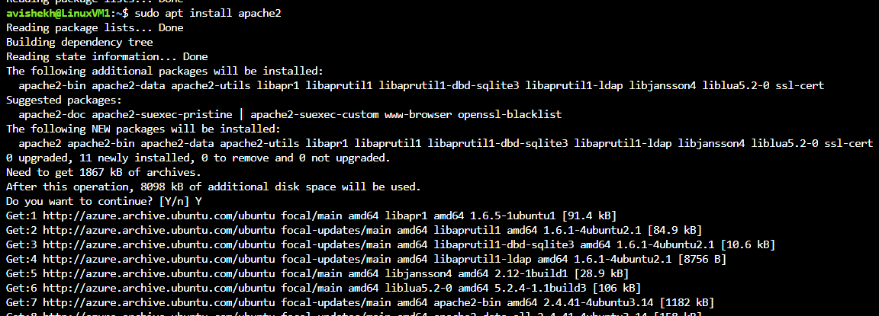

2. Change index.html to include the following text

|  |  |
| --- | --- |
| This is VM1” on VM1 |  |
| “This is VM2” on VM2 |  |

DISASSOCIATE PUBLIC IP FROM VMs

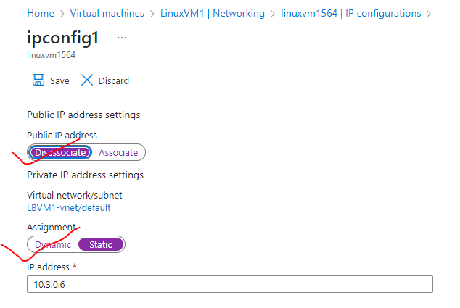

SET UP PUBLIC IP OF LOAD BALANCER

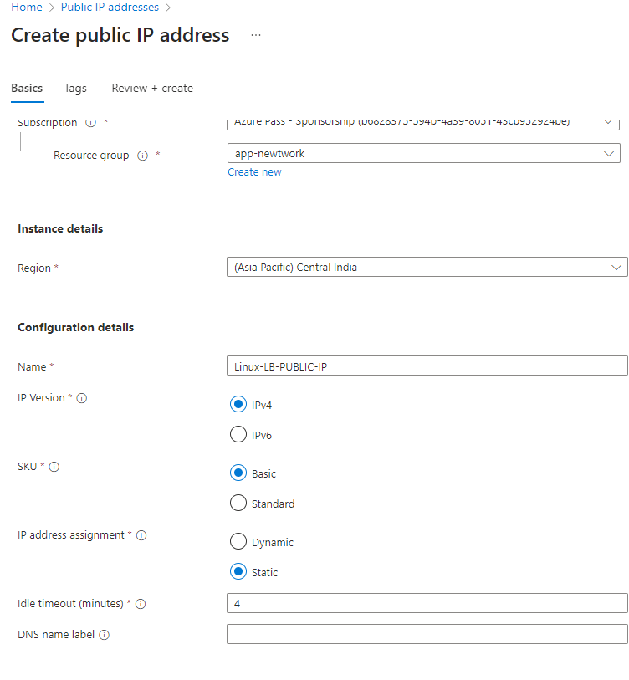

CREATING LOAD BALANCER

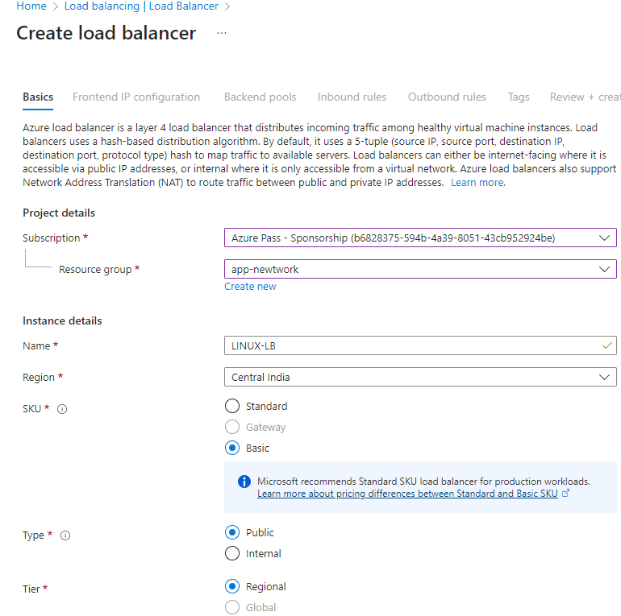

FRONTEND IP CONFIGURATION

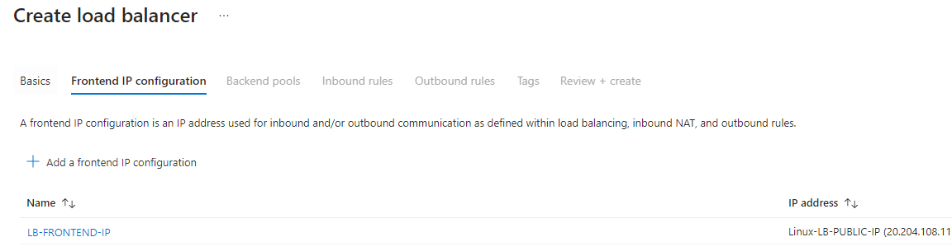

BACKEND POOL CONFIGURATION

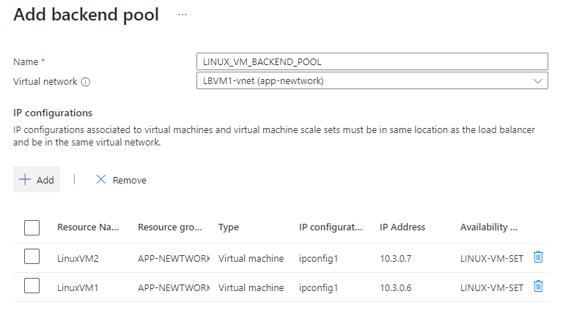

SETTING UP HEALTH PROBE

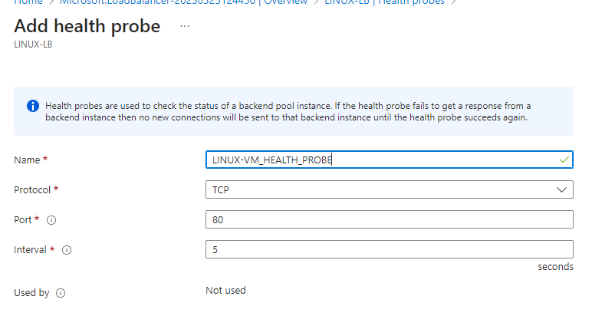

SETTING UP LOAD BALANCING RULE

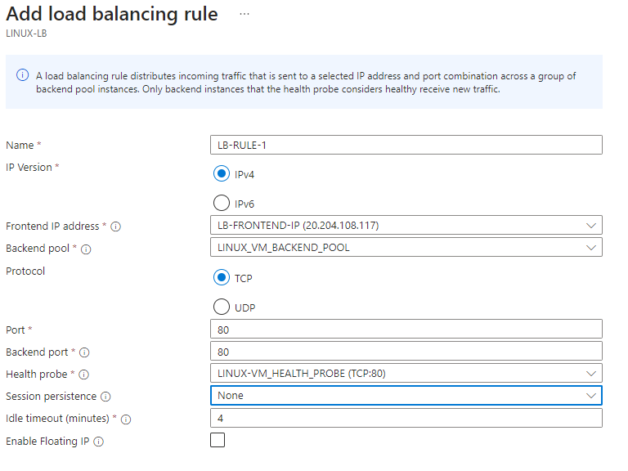

ACCESSING APPLICATION USING LOAD BALANCER’S PUBLIC IP

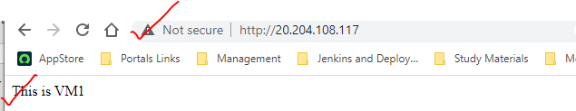

## Assignment 2

1. Create an application gateway with the following configuration

a. /vm1 should point to VM1

b. /vm2 should point to VM2

## Assignment 3

For the two VMs deployed previously

2. Configure DNS for the public IPs of the VM

## Assignment 4

1. Deploy 2 VMs in different regions

2. Balance the load on these VMs geographically

To accomplish this please use Azure Traffic Manager

## Assignment 5

1. Create a VM without Public IP address

2. Connect to this VM using Bastion host